Cod Tagging Programme

In order to compliment the tagging work being carried out by AFBI and the Marine Institute as part of a 3 year cod tagging programme running in the Irish Sea, a number of interested anglers and pot fishermen were recruited to tag cod. 16 anglers and 3 pot fishermen located at various sites along the east coast were individually trained by AFBI and Marine Institute tagging staff, and provided with a tagging kit to tag cod at any opportunity that arises for them.

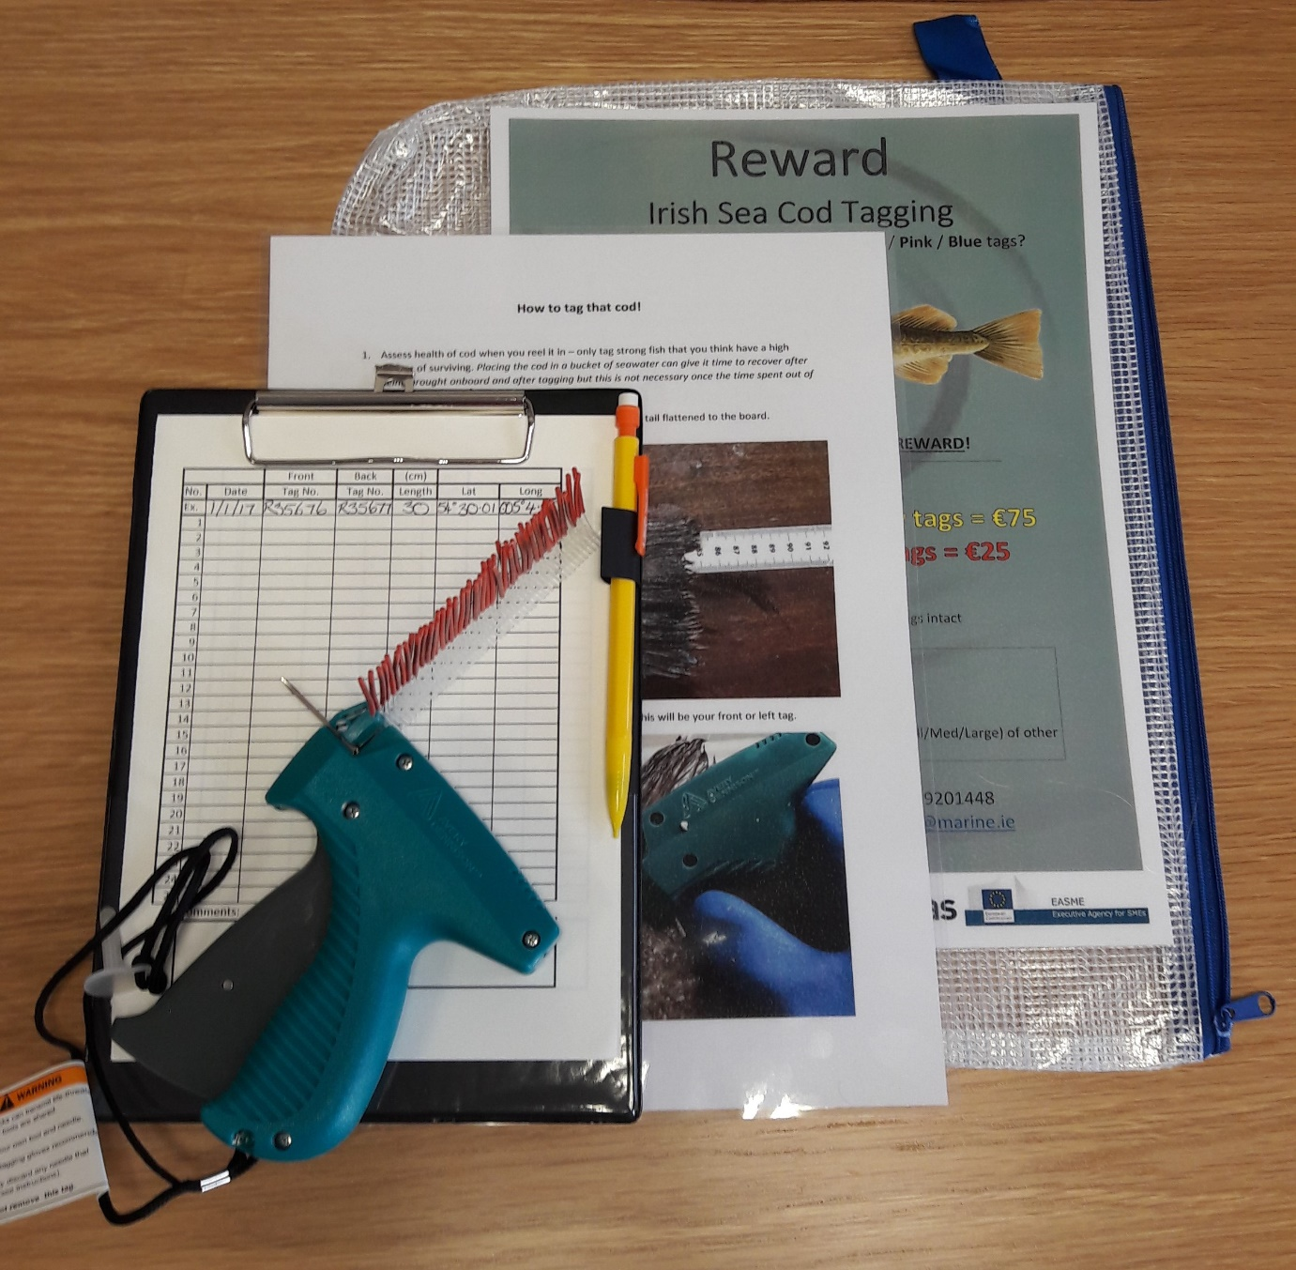

Tagging kit including tagging gun, floy tags, datasheets, SOP and reward poster.

The voluntary taggers consisted of a mixture of boat and shore anglers and pot fishermen who regularly encounter cod while fishing at sea or on the shore. The main aspects of the training provided included assessing whether the cod was healthy enough to be tagged, getting the tagger familiar with the equipment used to tag cod, the insertion and placement of the tags and recording the data.

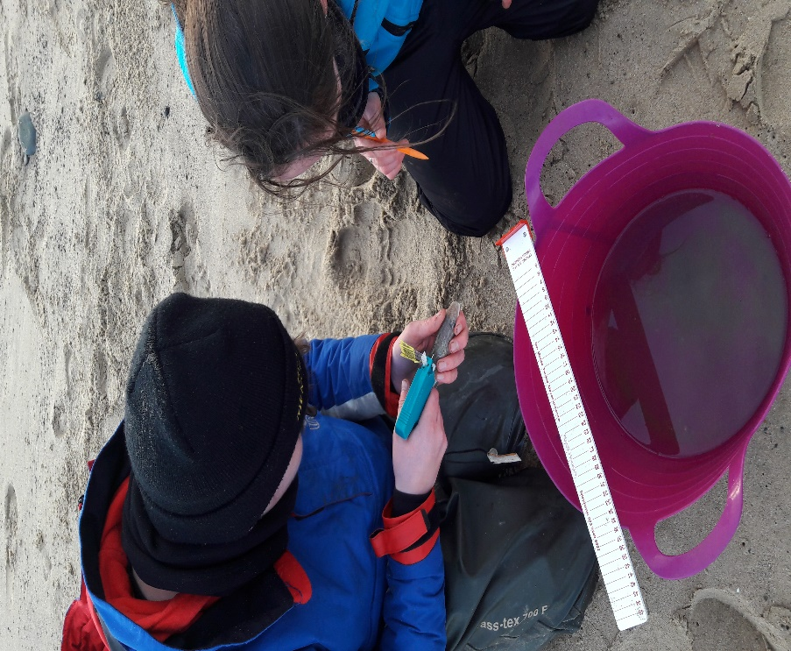

Marine Institute staff member training Ireland team and South Shore SAC angler Evan Ryan to tag cod on Arklow North Beach.

Recruiting voluntary taggers has huge benefits overall for the project including, stakeholder engagement, number of tags being released, areas being sampled and project outreach.